A Objective
This lab develops the skills to add and manage users and groups with the Linux operating systems using shell commands. Further, the lab will look behind the scenes of user management in Linux by analyzing the content of the corresponding configuration files. In the second part of this lab, as a more real-world example, we will create the users of a small company called Gotham City!

B Platform and process
- You will need a Linux-system where you have superuser (root) privileges (with sudo or su) – employ one of the prepared VMs running e.g. Kali Linux (the privileged user is called kali or junioradmin)!
- Execute all commands in a terminal window using the standard shell and don’t forget to elevate your privileges first using e.g. sudo su!
→ Be sure to provide answers to all questions and to document each and every shell command line in your lab notes (lab report)!

C Existing users
(1) A regular linux user belongs to many groups.
- Login as user junioradmin. Which group(s) are you in the (virtual machine) in? Hint: use the id command.
- Why are there so many groups?
- What about user kali (password: kali) in the virtual machine – which groups is he in?

D Creating a new user
- Create a new group called heroesNN ! Note: replace NN by the last two digits of your login-number!
Which (simple) command line did you use to create the new user group?
- Changes
  - Which (text) file in /etc received a new entry as a consequence to step (2)?
/etc/group
  - List the corresponding line from the group file using the command grep!
Command: grep heroes28 /etc/group
Result: heroes28:x:1002:
  - What is the group id of the group heroesNN?
1002
  - Try the following command lines – what is the purpose of each?
getent passwd queries user database
getent group queries group database
d. What else can getent show? Tipp: Just use tabulator-key on command-line or check the manual pages.
hosts, services, protocols, networks, etc.
- Create a new user with the following specs – use only one single shell command line:
  - User name: max
  - Full name: Max Headroom
  - Home directory:/home/max
  - Shell: /bin/bash
  - “Main” group (= Login Group): heroesNN
  - What command line did you use to create the user
sudo useradd -m -c "Max Headroom" -d /home/max -s /bin/bash -g heroes28 max
  - What (text) system files consequently received new entries - enter the absolute path?
List the corresponding lines from the passwd file using the command grep!
/etc/passwd, /etc/shadow
  - What is the (numerical) user id of user max?
1002
  - Is it already possible for the user max to login?
No — password not set yet
- Configure a secure password for user max!
  - How did you do that?
Used passwd command
  - What text file in /etc was changed when adding the password? List the corresponding line with grep!
Which command did you use?
File: /etc/shadow — check with grep max /etc/shadow
- Try to login with user name max – does it work? (If not, what error message do you receive? See (7) )
  - … with the command su -username. What does the command su stand for?
Switch user
Does it work?
yes
What does the strange option “-” mean?
The "-" loads a full login environment
  - … via the network using ssh: sshusername@localhost Does it work?
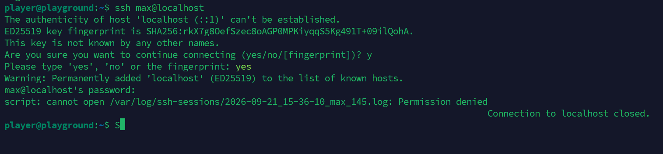
Authentication works, but the SSH session is closed due to an error at /var/log/ssh-sessions/
  - If a) and/or b) work, try to login by using the graphical user interface (GUI)!
Does it work?
I don’t have a GUI

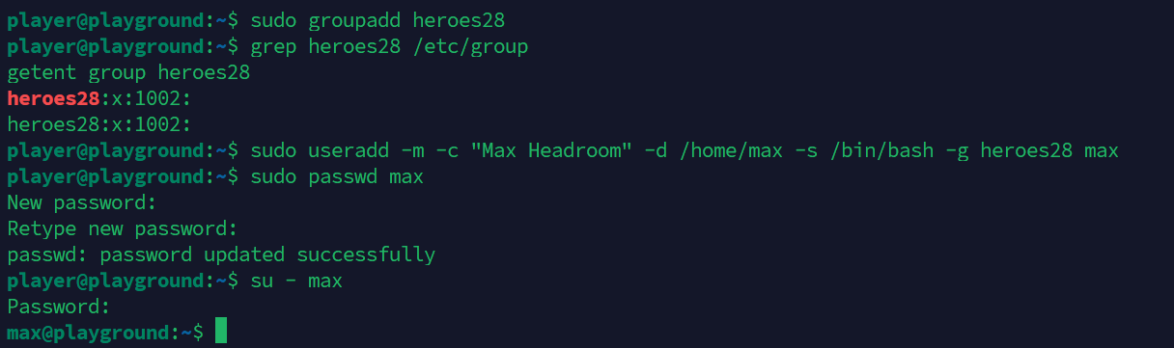
- Only if (6) did not work (couldn’t login): Check if perhaps the home directory of max does not exist at all (how do you check this?) or if maybe the password has not been set (where would you check this?)
  - If the home directory does not exist (you may have missed to pass the correct option to useradd), you will need to create it using mkdir. The owner should be max – and max should have all permissions to his own directory – does the login work now?
  - So what was the cause of the problem?
Does it work?

E Creating multiple users
(8) Create the following users, groups and directories on the system:
a. … with the help of the simple Shell Script addusers.sh (include it in your lab report – you will need it again later!):
Hint 1: It is easiest to create the script file with an editor (vi, nano, gedit…). For each new user, enter a useradd command per line. You can execute the script with sudo bash scriptfile. This will start the script with superuser (root)-privileges. In this case you don’t need sudo in front of
each line in your script!
Hint 2: It is a good idea to create both the groups (friends, heroesNN, …) and the higher-level folders (/home/friends, /home/heroesNN, …) first, before adding the users!
Hint 3: You may want to automate adding passwords by entering them directly in the script file
(what is the potential problem here?) – to achieve this, you cannot use the passwd command, as it expects input directly from the console. Use the command chpasswd (which reads from standard input, which in turn can be redirected from a pipe) instead, e.g.: echousername:password| chpasswd
Hint 4: It would be smart to make backup copies of all three (important) user management files in /etc before creating the groups and users – how do you do that?
b. List of users: Note: replace NN by the last two digits of your login-number!
Username | Full Name | Login Group | Home Directory | Password
adminNN | YourName | heroesNN | /home/heroesNN/adminNN | linux!is!c00l!
batman | Bruce Wayne | heroesNN | /home/heroesNN/batman | darkknight
robin | Dick Grayson | friends | /home/friends/robin | nightwing
catwoman | Selina Kyle | friends | /home/friends/catwoman | meowmeow
gordon | James Gordon | police | /home/police/gordon | law-n-order
joker | The Joker | villains | /home/villains/joker | whysoserious
penguin | Oswald Cobblepot | villains | /home/villains/penguin | fish!
- a. Ensure that all users (including their home directories) have been successfully created – you can test this by logging in via the GUI or directly in the terminal using su -username!
  - How secure are above passwords?
Very insecure
  - Your script to create the users
  - Write and test a second script file delusers.shthat deletes all the users, groups and directories again! Insert your script as text here:
#!/bin/bash

# Delete users and their home directories
userdel -r adminNN
userdel -r batman
userdel -r robin
userdel -r catwoman
userdel -r gordon
userdel -r joker
userdel -r penguin

# Delete groups
groupdel heroesNN
groupdel friends
groupdel police
groupdel villains

# Delete remaining directories
rm -rf /home/heroes28
rm -rf /home/friends
rm -rf /home/police
rm -rf /home/villains
- Bonus ;-): Who is/was Max Headroom? Where does his name come from?
We wish you lots of success and fun with the exercise!
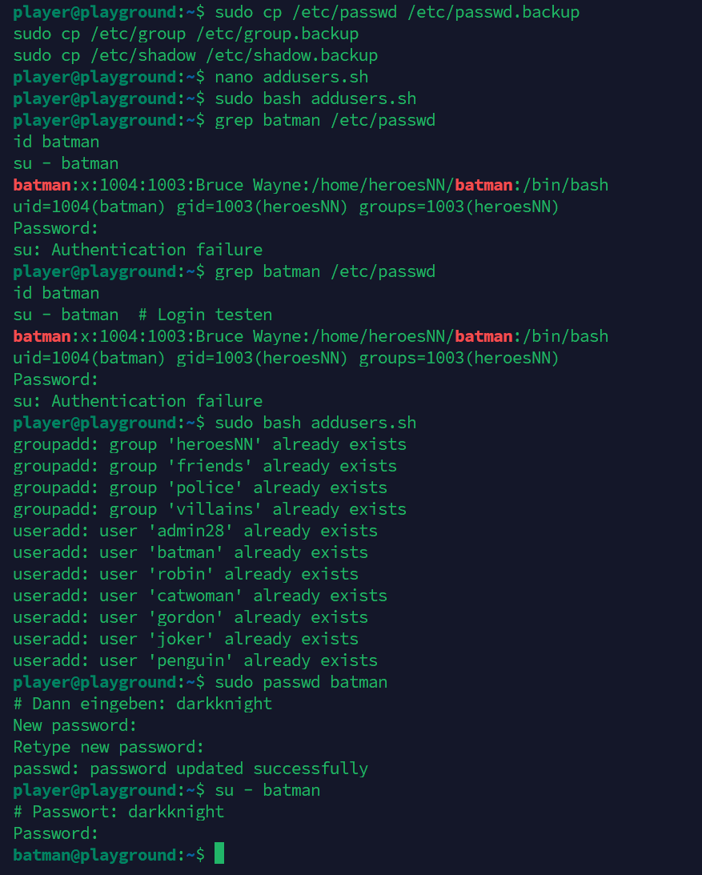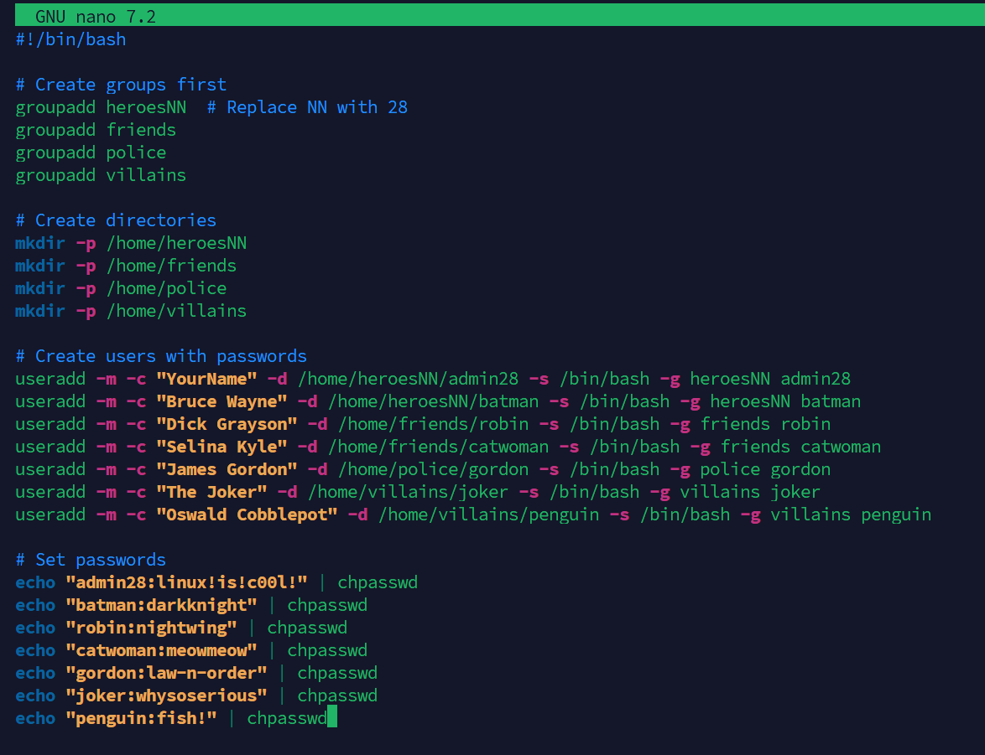

note the mnemonic trick for the important options of useradd: Getting something done makes charts green ;-)
you may need to install & activate an SSH-Server first, you can do this using sudo apt-get install openssh-server and sudo systemctl start ssh

